2nd Avenue Campus
School of Management Sciences
Tel. +27 (0)41 504 2202 /+27 (0)504 4301
Madele.Tait@mandela.ac.za

SCHOOL Research Committee meeting dates: 2018
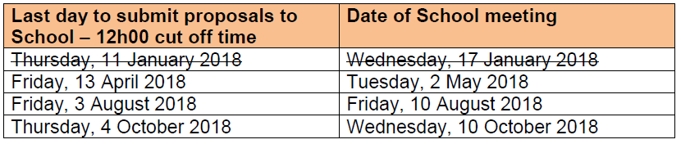
FACULTY Research Proposal Committee meetings: 2018
