2nd Avenue Campus
School of Management Sciences
Tel. +27 (0)41 504 2202/+27 (0)504 4301
Madele.Tait@mandela.ac.za

PROCESS FOR SUBMITTING RESEARCH PROPOSALS TO THE
SCHOOL RTI COMMITTEE

- The Supervisor submits final research proposal in electronic format to Vanessa Smith as per the dates indicated in the table below.
- The School Research Committee meetings will take place as indicated in the table below.
- The Supervisors will be informed of the outcome of the meeting no later than three (3) days after the meeting
- If the proposal is accepted by the School RTI, a School approval letter will be attached to the outcome
- If the proposal is not accepted, feedback with suggested changes will be attached to the outcome
- It is the responsibility of the supervisor to inform the student and co-supervisors about the outcome of the School RTI committee
- If the proposal is accepted and the necessary corrections have been made, the proposal can be submitted to the Faculty RTI, as per the dates below
- The School acceptance letter, as well as feedback from the School meeting also needs to be submitted to Ms Lindie van Rensburg, together with the documents requested by the Faculty RTI
- The School research committee mainly comment on the title and format of the proposal (not content)
SCHOOL Research Committee meeting dates: 2018
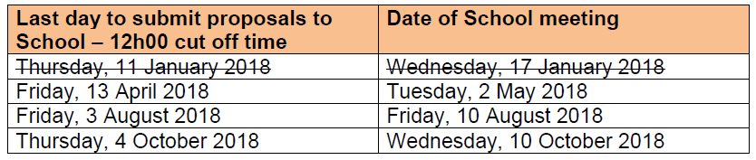
FACULTY Research Proposal Committee meetings: 2018
